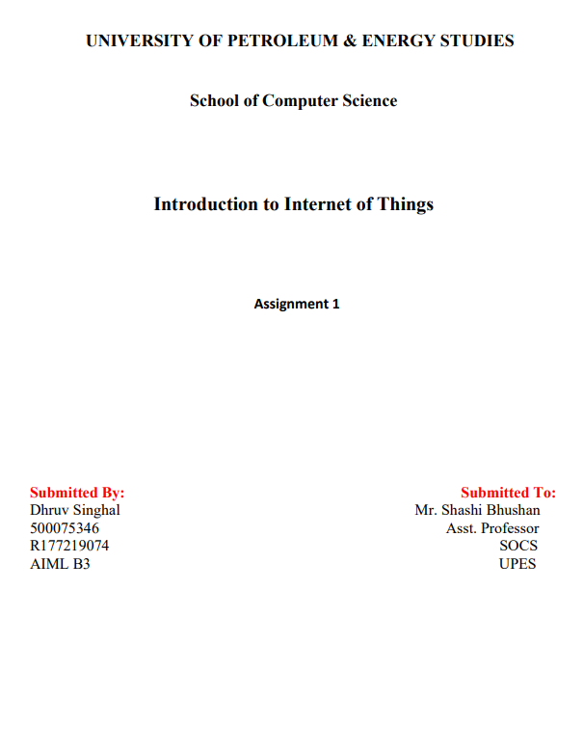

**Q 1 Explain IOT and its applications in detail.**

The term Internet of Things generally refers to scenarios where network connectivity and computing capability extends to objects, sensors and everyday items not normally considered computers, allowing these devices to generate, exchange and consume data with minimal human intervention There is, however, no single, universal definition

The concept of combining computers, sensors , and networks to monitor and control devices has existed for decades. The recent confluence of several technology market trends, however, is bringing the Internet of Things closer to widespread reality. These include Ubiquitous Connectivity, Widespread Adoption of IP-based Networking Computing Economics, Miniaturization, Advances in Data Analytics, and the Rise of cloud Computing

**Applications of IOT:**

**Healthcare Application:** These days we have digital watches and fitness monitoring devices that have changed the ways of healthcare monitoring. People can now monitor their own health at regular intervals of time These days if a person is being rushed to the hospital by an ambulance, his/her healthcare statistics are already given to the doctor, and the treatment gets started well in time. Also, data collected from different patients are now being put to use for the cure.

**Energy Applications:** The energy rates have become paramount. All Individuals and organizations, both are searching for ways to reduce and control the consumption of energy. IoT provides a way to monitor energy usages not only at the appliance level but also at the grid level, house level or even at the distribution level smart systems such as meters & Smart Grids are installed at various organizations to monitor energy consumption.

**Education Applications:** IoT’s yet another great application lies in the field of education IoT helps in fulfilling the gaps and loopholes in the education industry It improves the quality of education being offered to students by optimizing the cost. It also improves administration and management by taking into consideration students responses and performance

**Government Applications**:The smart city initiative by our government is an example of how efficient and big this technology is. It's incorporation in sectors like transportation, healthcare, armed forces, and security is commendable

Apart from these there are various applications of IoT such as –

**Water Supply**

**International Border Surveillance**

**Hospitality**

**Environment Monitoring**

**Automated Transportation & many more**

**Q2: Explain the following:**

**a) Asset Management**

**IOT is very helpful in terms of asset management.**

**Real-Time Information**

IOT is capable of getting real-time information which can play a crucial role in future events and planning For instance, let us take an agriculture-based organization As the human population grows continuously. so does the demand for and supply of food smart farming with IOT is one of the rapidly growing sectors

**Decrease Human Involvement**

IOT enabled asset management uses sensors. This empowers organizations to know their assets information, eliminating the need for human effort It actively keeps track of all assets through IOT sensors attached to each asset

**Asset Optimization**

IOT sensors keep track of asset performance with such information, the organization can make the appropriate decision in order to save expenses and extend the life of an asset.

**Asset & Cost Tracking**

IOT-empowered assets furnish information arising from the root cause of any problem It ensures that the issues are resolved, breakdown costs are saved and smart financial decisions can be taken in time

**Enhanced Monitoring Maintenance**

With IOT technology, an enterprise can monitor it's assets, machines, equipment, etc. in real-time. An IOT sensor can alert plant managers when the operating parameters of assets such as temperature or environment are not in the permissible range

**Security**

In spite of some concerns expressed for IOT devices, these asset trackers now come with better security. The IOT tracker uses data authentication and data encryption to ensure that the data is kept private and secure.

**b.) IoT Telemetry**

IOT devices communicate using several network protocols IOT devices used for telemetry such as remote sensors have the following requirements:

**Low Power**- Many IOT devices are powered from embedded battery new battery technologies have life expectancies of 10 to 20 years Low-

**Code Footprint** - IOT devices are required to be as small as possible. This requires lightweight protocols that do not need heavy computing or wireless transmission power requirements

**Low Bandwidth** - Higher bandwidth transmissions require higher power and additional hardware footprints

**Local Intelligent IOT Gateways**- The closer this system is to the IOT device, the lower the power required to transmit to this receiving system IOT telemetry communications between the devices and the receiving system are performed by several protocols. Each protocol has benefits and flaws.

**MQTT** - The Message Queuing Telemetry Transport (MQTT) protocol runs over TCP/IP and was designed for embedded hardware devices with limited embedded components and low power requirements. This protocol uses a publish-subscribe approach, which is inactive between transmissions and data retrievals. MQ TT requires an intelligent IOT gateway.

**CoAP** - Constrained Application Protocol (CoAP) was designed to run on devices constrained by low power and lossy networks. The protocol runs on UPP and is easily translatable to HTTP. CAP can be routed over IP networks and supports IP multicast for M2M communications between other IOT devices.

**HTTP** - This protocol is often combined with the Restful API protocol and is routable across the internet but is insecure

**HTTPS** - This protocol is secure and robust but has high power and processing requirements to encrypt data traffic and requires remote management of certificates.

**Q3: Discuss the application area of MQTT.**

MQTT is known as Message Queuing Telemetry Transport Protocol It is a lightweight messaging protocol and helps resource-constrained network clients with a simple communication mechanism. Unlike, most messaging systems, we don't have to assign addresses to MQTT clients

MQ TT uses simple publish/ subscribe communication-based on a topic This protocol runs on top of TCP / IP in order to provide reliable data delivery.

**Application Areas of MQTT**

Due to its lightweight properties, MQTT works well for applications involving remote monitoring, including the following:

synchronization of sensors, such as fire detectors or motion sensors for theft detection, to determine if a hazard is valid

monitoring health parameters using sensors for patients leaving a hospital and sensors alerting people of danger

**Examples of MQTT use in IOT infrastructure include the following:**

**smart metering**. The MQTT protocol can be used to transmit data with guaranteed message delivery to provide accurate meter readings in real time. This helps make billing more accurate

**Gathering ambient sensor data**. Sensors used in remote environments are often low-power devices, so MQTT is a good fit for IOT sensor buildouts with lower-priority data transmission needs.

**Billing systems**, MQTT helps eliminate duplicate or lost message packets in billing or invoicing.

**Q4: Explain CoAP in detail.**

Constrained Application Protocol (CoAP) is a specialized web transfer protocol for use with constrained nodes and constrained networks in the Internet of Things COAP is designed to enable simple, constrained devices to join the IOT even though constrained networks with low bandwidth and low availability It is generally used for machine-to machine (M2M) applications such as smart energy and building automation

As it is designed for web applications it is also known as " The web of

Things Protocol " It can be used to transport data from few bytes to 1000s of bytes over web applications. It exists between the UDP layer and The Constrained Application Protocol (CAP) is a session layer protocol designed by IE TF constrained RESTful Environment (CORE) working group to provide a lightweight RESTful (HTTP interface. Representational State Transfer (REST) is the standard interface between HTTP client and servers. Lightweight applications such as those in NOT could result in insignificant overhead and power consumption by REST

COAP is designed to enable low-power sensors to use RESTful services while meeting their power constraints.

Built over UDP, instead of TCP (which is commonly used with HTTP, and has a light mechanism to provide reliability.

**COAP architecture is divided into two main sub-layers:**

**Messaging**

**Request/response**

The messaging sub-layer is responsible for the reliability and duplication of messages, while the request/response sub-layer is responsible for communication

**CoAP has four messaging modes:**

**confirmable**

**Non-confirmable**

**Piggyback**

**Separate**

**CoAP Features**

**1: web Protocol Used in M2M with Constrained Requirements**

**2: Asynchronous Message Exchange**

**3. Very Simple to Perform Syntactic Analysis**

**4: Uniform Resource Identifier**

**5: supports binding to UDP, SMS and TCP**

**COAP Message Type:**

* confirmable and non-confirmable modes represent the reliable and unreliable transmissions, respectively, while the other modes are used for request/response,
* Piggyback is used for client/server direct communication where the server sends its response directly after receiving the message, i.e., within the acknowledgement message.
* On the other hand , the separate mode is used when the server response comes in a message separate from the acknowledgement, and may take some time to be sent by the server
* Similar to HTTP, CAP utilizes GET, PUT, PUSH, DELETE messages requests to retrieve, create, update , and delete, respectively